Image Denoising Techniques
专业班级：15计科2 学号：1501011026 姓名：刘飞鸿 指导老师签字： 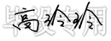
The main challenge in digital image processing is to remove noise from the original image. This paper reviews the existing denoising algorithms and performs their comparative study. Different noise models including additive and multiplicative types are discussed in the paper.Selection of the denoising algorithm is application dependent. Hence, it is necessary to have knowledge about the noise present in the image so as to select the appropriate denoising algorithm. Here we put results of different approaches of wavelet based image denoising methods using several thresholding techniques such as BayesShrink,SureShrink, and VisuShrink.A quantitative measure of comparison is provided by SNR (signal to noise ratio) and mean square error (MSE).
INTRODUCTION
Digital images plays very significant role in our daily routine like they are used in satellite television, Intelligent traffic monitoring, handwriting recognition on checks, signature validation, computer resonance imaging and in area of research and technology such as geographical information systems and astronomy. In digital imaging, the acquisition techniques and systems introduce various types of noises and artifacts. Denoising is more significant than any other tasks in image processing, analysis and applications. Reserving the details of an image and removing the random noise as far as possible is the goal of image denoising approaches. Besides the noisy image produces undesirable visual quality, it also lowers the visibility of low contrast objects. Hence noise removal is essential in digital imaging applications in order to enhance and recover fine details that are hidden in the data. In many occasions, noise in digital images is found to be additive in nature with uniform power in the whole bandwidth and with Gaussian probability distribution. Such a noise is referred to as Additive White Gaussian Noise (AWGN). It is difficult to Suppress AWGN since it corrupts almost all pixels in an image. In denoising there is always a tradeoff between noise suppression and preserving actual image discontinuities. To remove noise without excessive smoothing of important details, a denoising technique needs to be spatially adaptive. Different techniques are used depending on the noise model. Due to properties like sparsity, an edge detection and multiresolution , the wavelets naturally facilitates such spatially adaptive noise filtering.
The paper is organized as follows: Section II contains Evolution of Image Denoising Techniques. Section III contains survey of the related work in which various image denoising techniques are explained and then comparison of these methods is given in table2.
EVOLUTION OF IMAGE DENOISING TECHNIQUES
Image denoising is the fundamental problem in Image processing. Wavelet gives the excellent performance in field of image denoising because of sparsity and multiresolution structure. With the popularity of Wavelet Transform for the last two decades, several algorithms have been developed in wavelet domain. The focus was shifted to Wavelet domain from spatial and Fourier domain. Ever since the Donoho’s wavelet based thresholding approach was published in 2003, there was surge in the image denoising papers being published. Although his approach was not revolutionary, it did not require tracking and correlation of the wavelet maxima and minima across the different scales as proposed by Mallat.Thus there was renewed interest in wavelet approach since Donoho’s demonstrated a simple solution to difficult problem domain. Researchers published different approaches to compute the simulation parameters for wavelet coefficients. To achieve optimum threshold value , data adaptive threshold were introduced. Substantial improvements in perceptual quality could be obtained by translation invariant method based on thresholding of an Undecimated Wavelet transform. Much effort has been devoted to Bayesian denoising in wavelet domain. Gaussian scale mixtures and hidden markov models have also become popular and more research is continued to be published and Independent component analyses (ICA) have been explored in data adaptive components. Different statistical models are focused to model the statistical properties of wavelet coefficients and its neighbours. Future trend will be to find more probabilistic model for non-orthogonal wavelet coefficients distribution.
RELATED WORK
There has been a significant amount of work done on image denoising techniques. Existing methods are able to produce good results in many practical scenarios. The various denoising techniques are as follows:
Spatial Filtering
A traditional way to remove noise from image data is to employ spatial filters. Spatial filtering is commonly used to clean up the output of lasers, removing aberrations in the beam due to imperfect , dirty or damaged optics. Spatial filters can be further classified into non-linear and linear filters.
Linear Filters
Linear filters process time-varying input signals to produce output signals, subject to constraint of linearity. A mean filter is the optimal linear filter for Gaussian noise in the sense of mean square error. Linear filters too tend to blur sharp edges, destroy lines and other fine image details, and perform poorly in the presence of signal-dependent noise. The wiener filtering method requires the information about the spectra of the noise and the original signal and it works well only if the underlying signal is smooth. Wiener method implements spatial smoothing and its model complexity control correspond to choosing the window size. To overcome the weakness of the Wiener filtering, Donoho and Johnstone proposed the wavelet based denoising scheme in.
Mean Filter
A mean filter acts on an image by smoothing it; that is, it reduces the intensity variation between adjacent pixels. The mean filter is nothing but a simple sliding window spatial filter that replaces the center value in the window with the average of all the neighboring pixel values including itself. Image corrupted with salt and pepper noise is subjected to mean filtering and it can be observed that the noise dominating is reduced . The white and dark pixel values of the noise are changed to be closer to the pixel values of the surrounding ones. Also, the brightness of the input image remains unchanged because of the use of the mask, whose coefficients sum up to the value one.The mean filter is used in applications where the noise in certain regions of the image needs to be removed. In other words, the mean filter is useful when only a part of the image needs to be processed.
LMS Adaptive Filter
Adaptive filters are capable of denoising non-stationary images, that is, images that have abrupt changes in intensity. Such filters are known for their ability in automatically tracking an unknown circumstance or when a signal is variable with little a priori knowledge about the signal to be processed.An adaptive filter does a better job of denoising images compared to the averaging filter as the Least Mean Square (LMS) adaptive filter is known for its simplicity in computation and implementation. The LMS adaptive filter works well for images corrupted with salt and pepper type noise. But this filter does a better denoising job compared to the mean filter.
Non-linear filters
Non-linear filters have many applications, especially in removal of certain types of noise that are not additive. Generally spatial filters remove noise to a reasonable extent but at the cost of blurring images which in turn makes the edges in pictures invisible. In recent years, a variety of nonlinear median type filters such as weighted median, rank conditioned rank selection, and relaxed median have been developed to overcome this drawback.
Median Filter
The median filter also follows the moving window principle similar to the mean filter. A 3×3,5×5, or 7×7 kernel of pixels is scanned over pixel matrix of the entire image. The median of the pixel values in the window is computed, and the center pixel of the window is replaced with the computed median. The median is more robust compared to the mean. Thus, a single very unrepresentative pixel in a neighborhood will not affect the median value significantly.Since the median value must actually be the value of one of the pixels in the neighborhood, the median filter does not create new unrealistic pixel values when the filter straddles an edge. For this reason the median filter is much better at preserving sharp edges than the mean filter. These advantages aid median filters in denoising uniform noise as well from an image.
Spatial Median Filter
The spatial median filter is also noise removal filter where the spatial median is calculated by calculating the spatial depth between a point and a set of point. In this filter after finding out the spatial depth of each point lying within the filtering mask, this information is used to decide whether the central pixel of window is corrupted or not, If central pixel is uncorrupted then it will not be changed. We then find out the spatial depth of each pixel within the mask and then sort these spatial depths in descending order .The point with largest spatial depth represent the spatial median of the set.
Weighted Median Filter (WMF)
The centre weighted median filter is an extension of the weighted median filter. The weighted median filter previously designed gives more weight to some values within the window whereas centre weighted median filter gives more weight to the central value of a window thus easier to design and implement than other weighted median filter.
Wavelet Transforms
Wavelets are mathematical functions that analyze data according to scale or resolution. They aid in studying a signal in different windows or at different resolutions. For instance, if the signal is viewed in a large window, gross features can be noticed, but if viewed in a small window, only small features can be noticed. Wavelets provide some advantages over Fourier transforms. For example, they do a good job in approximating signals with sharp spikes or signals having discontinuities. The wavelet equation produces different wavelet families like Daubechies, Haar, Coiflets, etc.
Mallat’s Algorithm
Mallat’s algorithm is a computationally efficient method of implementing the wavelet transform. It calculates DWT wavelet coefficients for a finite set of input data, which is a power of 2. This input data is passed through two convolution functions, each of which creates an output stream that is half the length of the original input. This procedure is referred to as down sampling . Once the processing is done, the data vector is built back from the coefficients. This processes of reconstruction is referred to as the inverse Mallat’s algorithm.
Tables 1 shows the SNR (signal to noise ratio) of the input and output images for the filtering approach . It shows how SNR varies with different type of noise and filters used.
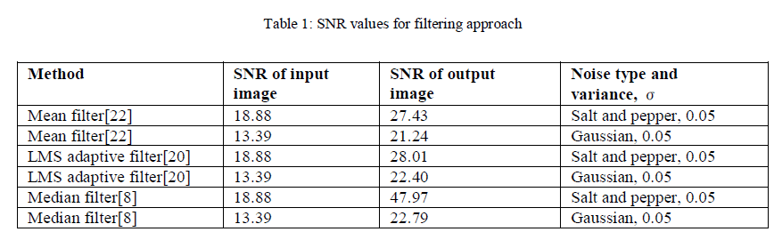
Wavelet Thresholding
Donoho and Johnstone pioneered the work on filtering of additive Gaussian noise using wavelet thresholding. Wavelet coefficients calculated by a wavelet transform represent change in the time series at a particular resolution. By considering the time series at various resolutions, it is then possible to filter out noise.The term wavelet thresholding is explained as decomposition of the data or the image into wavelet coefficients, comparing the detail coefficients with a given threshold value, and shrinking these coefficients close to zero to take away the effect of noise in the data. The image is reconstructed from the modified coefficients. There are various thresholding techniques. Some of these are discussed below:
VisuShrink
VisuShrink was introduced by Donoho. It uses a threshold value t that is proportional to the standard deviation of the noise. It follows the hard thresholding rule. It is also referred to as universal threshold and is defined as t =σ 2log n
VisuShrink does not deal with minimizing the mean squared error. It can be viewed as general-purpose threshold selectors that exhibit near optimal minimax error properties and ensures with high probability that the estimates are as smooth as the true underlying functions. However, VisuShrink is known to yield recovered images that are overly smoothed. This is because VisuShrink removes too many coefficients. Another disadvantage is that it cannot remove speckle noise. It can only deal with an additive noise. VisuShrink follows the global thresholding scheme where there is a single value of threshold applied globally to all the wavelet coefficients.
SureShrink
A threshold chooser based on Stein’s Unbiased Risk Estimator (SURE) was proposed by Donoho and Johnstone and is called as SureShrink. It is a combination of the universal threshold and the SURE threshold. The SureShrink threshold t* is defined as t* = min (t,σ 2log n )
where t denotes the value that minimizes Stein’s Unbiased Risk Estimator, σ is the noise variance and n is the size of the image.
SureShrink follows the soft thresholding rule. SureShrink suppresses noise by thresholding the empirical wavelet coefficients. SureShrink produces the best SNR as compared to VisuShrink and BayesShrink.
BayesShrink
BayesShrink was proposed by Chang, Yu and Vetterli. The goal of this method is to minimize the Bayesian risk, and hence its name, BayesShrink. It uses soft thresholding and is subband-dependent, which means that thresholding is done at each band of resolution in the wavelet decomposition. Like the SureShrink procedure, it is smoothness adaptive. The Bayes threshold, tB, is defined as tB =σ2 /σ s .
where σ2 is the noise variance and σ2 is the signal variance without noise.
The output from BayesShrink method is much closer to the high quality image and there is no blurring in the output image unlike the other two methods.
Table 2 shows the comparison of three thresholding methods used for image denoising for five different images. The output is dependent on respective method used and the simulated results in terms of PSNR ( peak signal to noise ratio) and MMSE (minimum mean square error).
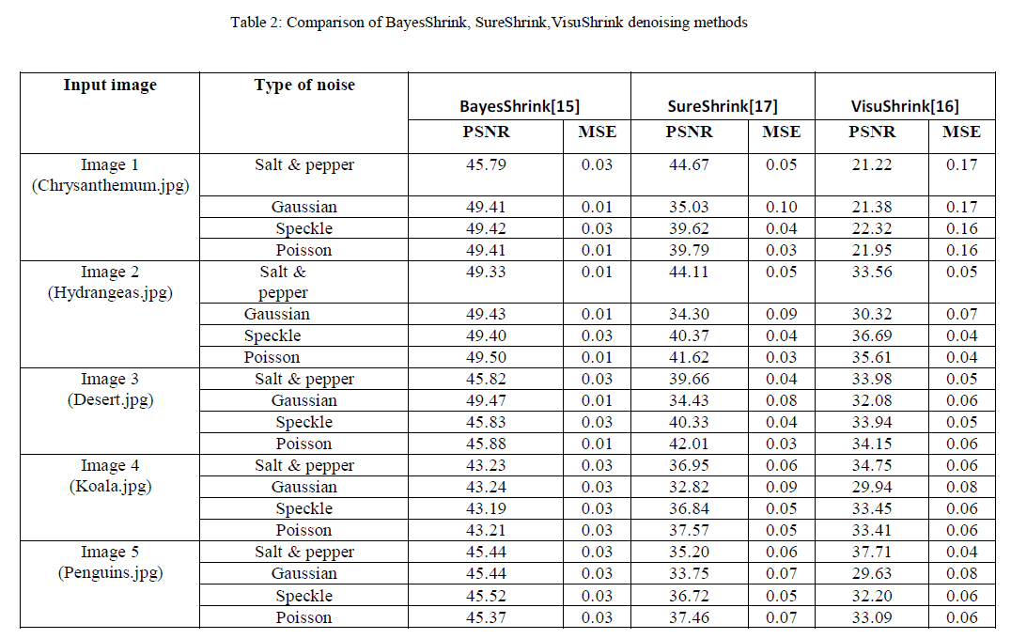
CONCLUSION
In this paper different denoising techniques are discussed. It can be concluded that for salt and pepper noise, the median filter is optimal compared to mean filter and LMS adaptive filter. It produces the maximum SNR for the output image compared to the linear filters considered. The LMS adaptive filter proves to be better than the mean filter but has more time complexity. The image obtained from the median filter has very less noise present in it and is close to the high quality image. The sharpness of the image is retained unlike in the case of linear filtering. In the case where an image is corrupted with Gaussian noise, the wavelet shrinkage denoising has proved to be nearly optimal. SureShrink produces the best SNR compared to VisuShrink and BayesShrink. However, the output from BayesShrink method is much closer to the high quality image and there is no blurring in the image unlike the other two methods. VisuShrink cannot denoise multiplicative noise unlike BayesShrink. From the obtained results it is visible that BayesInvariant thresholding technique in comparison has the highest PSNR values and minimum MMSE. SureShrink technique has high PSNR and comparatively high MMSE as compared to BayesInvariant thresholding technique. On the other hand VisuShrink method takes highest computation time and has lowest PSNR and much Higher MMSE vales. An important point to note is that although SureShrink performed a little poor than BayesInvariant based on PSNR and MMSE denoising, it adapts well to sharp discontinuities in the image. Thus to summarize BayesInvariant thresholding technique has best performance, SureShrink is better whereas VisuShrink is comparatively poor in performance.

图像去噪技术
专业班级：15计科2 学号：1501011026 姓名：刘飞鸿 指导老师签字：
数字图像处理的主要挑战是去除原始图像中的噪声。本文回顾了现有的去噪算法，并进行了比较研究。本文讨论了包括加法和乘法类型的不同噪声模型。去噪算法的选择取决于应用。因此，有必要了解图像中存在的噪声，以便选择适当的去噪算法。在这里，我们使用几种阈值技术（如BayesShrink，SureShrink和VisuShrink）放置基于小波的图像去噪方法的不同方法的结果。通过SNR（信噪比）和均方误差（MSE）提供比较的定量测量。
介绍
数字图像在我们的日常生活中起着非常重要的作用，如用于卫星电视，智能交通监控，支票上的手写识别，签名验证，计算机共振成像以及地理信息系统和天文学等研究和技术领域。在数字成像中，采集技术和系统引入了各种类型的噪声和伪像。去噪比图像处理，分析和应用中的任何其他任务更重要。保留图像的细节并尽可能去除随机噪声是图像去噪方法的目标。除了嘈杂的图像产生不希望的视觉质量外，它还降低了低对比度物体的可见度。因此，噪声消除在数字成像应用中是必不可少的，以便增强和恢复隐藏在数据中的精细细节。在许多情况下，发现数字图像中的噪声本质上是附加的，在整个带宽中具有均匀的功率并且具有高斯概率分布。这种噪声被称为加性高斯白噪声（AWGN）。很难抑制AWGN，因为它几乎破坏了图像中的所有像素。在去噪中，总是在噪声抑制和保持实际图像不连续之间进行权衡。为了在不过度平滑重要细节的情况下去除噪声，去噪技术需要在空间上自适应。根据噪声模型使用不同的技术。由于稀疏性，边缘检测和多分辨率等特性，小波自然地促进了这种空间自适应噪声滤波。
本文的结构如下：第二部分包含图像去噪技术的演变。第三节包含对相关工作的调查，其中解释了各种图像去噪技术，然后在表2中给出了这些方法的比较。
图像去噪技术的演变
图像去噪是图像处理中的基本问题。由于稀疏性和多分辨率结构，小波在图像去噪领域具有优异的性能。随着小波变换在过去二十年中的流行，已经在小波域中开发了几种算法。重点从空间和傅里叶域转移到小波域。自从Donoho基于小波的阈值处理方法于2003年出版以来，出版的图像去噪论文激增。尽管他的方法不是革命性的，但它并不需要像Mallat提出的那样在不同尺度上跟踪和关联小波最大值和最小值。因此，由于Donoho的证明了一个简单的解决方案，因此对小波方法有了新的兴趣。困难的问题领域。研究人员发表了不同的方法来计算小波系数的模拟参数。为了达到最佳阈值，引入了数据自适应阈值。基于Undecimated小波变换阈值的平移不变方法可以获得感知质量的显着提高。在小波域中已经投入了很多努力来进行贝叶斯去噪。高斯尺度混合和隐马尔可夫模型也变得流行，并且更多的研究将继续发表，并且已经在数据自适应组件中探索了独立成分分析（ICA）。不同的统计模型专注于模拟小波系数及其邻居的统计特性。未来的趋势是为非正交小波系数分布找到更多的概率模型。
相关工作
在图像去噪技术方面已经做了大量的工作。现有方法能够在许多实际场景中产生良好的结果。各种去噪技术如下：
空间过滤
从图像数据中去除噪声的传统方法是使用空间滤波器。空间滤波通常用于清除激光器的输出，消除由于不完美，脏污或损坏的光学器件引起的光束畸变。空间滤波器可以进一步分为非线性和线性滤波器。
线性滤波器
线性滤波器处理时变输入信号以产生输出信号，受线性约束。均值滤波器是均方误差意义下的高斯噪声的最佳线性滤波器。线性滤波器也倾向于模糊锐边，破坏线条和其他精细图像细节，并且在存在信号相关噪声的情况下表现不佳。维纳滤波方法需要有关噪声和原始信号频谱的信息，并且只有当基础信号平滑时才能正常工作。维纳方法实现空间平滑，其模型复杂度控制对应于选择窗口大小。为了克服Wiener滤波的弱点，Donoho和Johnstone在中提出了基于小波的去噪方案。
均值滤波器
平均滤波器通过平滑它作用于图像;也就是说，它减少了相邻像素之间的强度变化。均值滤波器只不过是一个简单的滑动窗口空间滤波器，它将窗口中的中心值替换为包括其自身在内的所有相邻像素值的平均值。用盐和胡椒噪声破坏的图像经受均值滤波，并且可以观察到噪声占主导地位的降低。噪声的白色和暗色像素值被改变为更接近周围像素值的像素值。此外，由于使用了掩模，输入图像的亮度保持不变，其系数总和为值1.平均滤波器用于需要去除图像的某些区域中的噪声的应用中。换句话说，当仅需要处理图像的一部分时，均值滤波器是有用的。
LMS自适应滤波器
自适应滤波器能够对非静止图像进行去噪，即，具有强度突然变化的图像。这种滤波器因其能够自动跟踪未知环境或信号变化而知之甚少，而且对待处理信号的先验知识很少。与平均滤波器相比，自适应滤波器可以更好地对图像进行去噪处理。最小均方（LMS）自适应滤波器因其计算和实现简单而闻名。 LMS自适应滤波器适用于被盐和胡椒类型噪声破坏的图像。但与平均滤波器相比，此滤波器可以做更好的去噪工作。
非线性滤波器
非线性滤波器具有许多应用，特别是在去除某些类型的非附加噪声时。通常，空间滤波器在合理的范围内去除噪声，但是以图像模糊为代价，这反过来使图像中的边缘不可见。近年来，已经开发了各种非线性中值型滤波器，例如加权中值，秩条件秩选择和松弛中值以克服该缺点。
中位数过滤器
中值滤波器也遵循类似于均值滤波器的移动窗口原理。在整个图像的像素矩阵上扫描3×3,5×5或7×7像素核。计算窗口中像素值的中值，并用计算出的中值替换窗口的中心像素。与平均值相比，中位数更加稳健。因此，邻域中的单个非常不具代表性的像素将不会显着影响中值。由于中值必须实际上是邻域中的一个像素的值，因此当滤波器跨越时，中值滤波器不会创建新的不切实际的像素值边缘。由于这个原因，中值滤波器在保持锐边缘方面要比平均滤波器好得多。这些优点有助于中值滤波器从图像中去除均匀噪声。
空间中值过滤器
空间中值滤波器也是噪声去除滤波器，其中通过计算点和一组点之间的空间深度来计算空间中值。在找到位于过滤掩模内的每个点的空间深度之后，在该过滤器中，该信息用于判断窗口的中心像素是否被破坏，如果中心像素未被破坏则不会被改变。然后我们找出掩模内每个像素的空间深度，然后按降序对这些空间深度进行排序。具有最大空间深度的点表示该集合的空间中值。
加权中值滤波器（WMF）
中心加权中值滤波器是加权中值滤波器的扩展。先前设计的加权中值滤波器给窗口内的某些值赋予更多权重，而中心加权中值滤波器给予窗口中心值更多权重，因此比其他加权中值滤波器更容易设计和实现。
小波变换
小波是根据比例或分辨率分析数据的数学函数。它们有助于研究不同窗口或不同分辨率的信号。例如，如果在大窗口中查看信号，则可以注意到粗略的特征，但是如果在小窗口中查看，则只能注意到小的特征。小波比傅里叶变换提供了一些优势。例如，它们在近似具有尖峰或具有不连续性的信号的信号方面做得很好。小波方程产生不同的小波族，如Daubechies，Haar，Coiflets等。
Mallat的算法
Mallat算法是一种实现小波变换的计算有效方法。它计算有限输入数据集的DWT小波系数，该输入数据是2的幂。该输入数据通过两个卷积函数，每个卷积函数创建一个输出流，其长度是原始输入的一半。此过程称为下采样。一旦处理完成，就从系数构建数据向量。这种重建过程称为逆Mallat算法。
表1显示了滤波方法的输入和输出图像的SNR（信噪比）。它显示了SNR如何随着使用的不同类型的噪声和滤波器而变化。
小波阈值
Donoho和Johnstone率先使用小波阈值法对加性高斯噪声进行滤波。通过小波变换计算的小波系数表示在特定分辨率下的时间序列的变化。通过考虑各种分辨率下的时间序列，可以滤除噪声。术语小波阈值解释为将数据或图像分解为小波系数，将细节系数与给定阈值进行比较，并缩小这些系数接近于零以消除数据中噪声的影响。从修改的系数重建图像。有各种阈值技术。其中一些讨论如下：
VisuShrink
VisuShrink由Donoho引入。它使用与噪声标准偏差成比例的阈值t。它遵循严格的阈值规则。它也被称为通用阈值，定义为t =σ2logn
VisuShrink不涉及最小化均方误差。它可以被视为通用阈值选择器，它具有接近最优的极小极大误差特性，并且很有可能确保估计与真正的基础函数一样平滑。然而，已知VisuShrink会产生过度平滑的恢复图像。这是因为VisuShrink删除了太多系数。另一个缺点是它不能去除斑点噪声。它只能处理加性噪声。 VisuShrink遵循全局阈值方案，其中对所有小波系数全局应用阈值的单个值。
SureShrink
Donoho和Johnstone提出了一种基于Stein无偏风险估计（SURE）的阈值选择器，称为SureShrink。它是通用阈值和SURE阈值的组合。 SureShrink阈值t *定义为t * = min（t，σ2logn）
其中t表示最小化Stein无偏风险估计的值，σ是噪声方差，n是图像的大小。
SureShrink遵循软阈值规则。 SureShrink通过对经验小波系数进行阈值处理来抑制噪声。与VisuShrink和BayesShrink相比，SureShrink产生最佳的SNR。
BayesShrink
BayesShrink由Chang，Yu和Vetterli 提出。此方法的目标是最小化贝叶斯风险，因此其名称为BayesShrink。它使用软阈值并且是子带相关的，这意味着在小波分解中的每个分辨率带处进行阈值处理。与SureShrink程序一样，它是平滑自适应的。贝叶斯阈值tB定义为tB =σ2/σs。
其中σ2是噪声方差，σ2是没有噪声的信号方差。
BayesShrink方法的输出更接近高质量图像，并且与其他两种方法不同，输出图像中没有模糊。
表2显示了用于五种不同图像的图像去噪的三种阈值方法的比较。输出取决于所使用的各个方法以及PSNR（峰值信噪比）和MMSE（最小均方误差）方面的模拟结果。
结论
在本文中，讨论了不同的去噪技术。可以得出结论，对于盐和胡椒噪声，与平均滤波器和LMS自适应滤波器相比，中值滤波器是最佳的。与所考虑的线性滤波器相比，它产生输出图像的最大SNR。 LMS自适应滤波器证明比均值滤波器更好，但具有更多的时间复杂度。从中值滤波器获得的图像中存在非常少的噪声并且接近高质量图像。与线性滤波的情况不同，保留了图像的清晰度。在图像被高斯噪声破坏的情况下，小波收缩去噪已被证明几乎是最佳的。与VisuShrink和BayesShrink相比，SureShrink产生最佳SNR。然而，BayesShrink方法的输出更接近高质量图像，并且与其他两种方法不同，图像中没有模糊。与BayesShrink不同，VisuShrink无法对乘法噪声进行去噪。从获得的结果可以看出，比较的BayesInvariant阈值技术具有最高的PSNR值和最小的MMSE。与BayesInvariant阈值技术相比，SureShrink技术具有高PSNR和相对较高的MMSE。另一方面，VisuShrink方法占用最高的计算时间，具有最低的PSNR和更高的MMSE值。需要注意的一点是，虽然SureShrink比基于PSNR和MMSE去噪的BayesInvariant表现稍差，但它能很好地适应图像中的尖锐不连续性。因此，总结BayesInvariant阈值技术具有最佳性能，SureShrink更好，而VisuShrink性能相对较差。

